THE USE OF FERROCEMENT TECHNOLOGY WITHIN FISHERY INDUSTRY ALIGNS WITH SUSTAINABLE DEVELOPMENT GOALS

Taufik Dwicahyono¹, Romie Oktovianus Bura^{2,3}, Januar Arief Martharaharja⁴, Lilly S. Wasitova⁵, Richardus Eko Indrajit⁶

¹PhD Student, Faculty of Defence Technology
Indonesia Defence University, Bogor 16810, Indonesia
²Faculty of Defense Technology
Indonesia Defence University, Bogor 16810, Indonesia
³Flight Physic Research Group, Faculty of Mechanical and Aerospace Engineering
Institut Teknologi Bandung, Jalan Ganesa 10 Bandung 40132, Indonesia
⁴PhD Student, Faculty of Defence Technology
Indonesia Defence University, Bogor 16810, Indonesia
⁵PhD Student, Faculty of Defence Strategy
Indonesia Defence University, Bogor 16810, Indonesia
⁶PhD Student, Faculty of Defence Strategy
Indonesia Defence University, Bogor 16810, Indonesia

Corresponding author: lilly.wasitova@idu.ac.id

ABSTRACT
Ferrocement has been used from over a hundred years ago, and reached its peak use in 1970’s, after the Vietnam War. One of the famous uses of ferrocement was called a “Bowl ship” which was based on transfer of technology from the US Navy. The application of ferrocement technology is diverse, starting from buoys used for ship navigation, to high-tech marine construction, such as offshore wind turbine poles. Combined with new technology such as additives, Ferrocement fishing vessels should be stronger, more effective, more efficient, and inexpensive. Due to lighter construction, the power-to-weight ratio will be greater, and the ship’s cruise should be better than wooden and steel vessels. In return, this will decrease fishermen’s operation costs and can help improve their standard of living. In that sense, the use of ferrocement is in line with the United Nations Sustainable Development Goals (SDGs), especially for the eradication of poverty. Another benefit of having low price-high performance vessels is that the population of the vessels can be increased dramatically with less effort in investments. As the result of the massive scale presence of these fishing vessels, national security can also be increased, and the national sovereignty of archipelagic nations can be ensured.

Keyword: Ferrocement, Sustainable Development Goals, National Security

Preface
The fishing industry in Indonesia plays an important role in economic growth, with coastal communities as the main players, namely people who live in coastal areas whose livelihoods depend directly on the utilization of marine and coastal resources. In daily life we ​​are accustomed to the mention of coastal communities as fishermen. According to Law No. 31 of 2004 concerning Fisheries, fishermen are defined as people whose livelihoods are fishing and divided into 4 categories of fishermen: 1) subsistence fishermen, fishermen who only meet their own needs using traditional fishing gear without motorboats, 2) fishermen who use motorboats to catch fish in more distant regions and greater catchability than subsistence fishermen 3) commercial fishermen, i.e. fishermen who are profit oriented and use modern technology and requires special expertise in the operation of ships and fishing gear. 4) industrial fishermen, capital-intensive fishermen, can maintain their catches so that they are export-oriented.
The four categories of fishermen describe the capture fisheries industry in Indonesia with a fishing fleet whose main components are ships of various categories and sizes.

Problem
Millions of fishermen across the country economically depend on the most efficient ship performance. There is stagnant growth of the motorized ship industry with declining tendency, while there is need for easier and more efficient methods of constructing marine vessels for fishermen with readily available materials, and cheap labor costs. Owning a fishing boat fleet certainly requires a large amount of capital for fishermen as well as the technical, economic and social review so that the fishing community can develop its own fleet that can reach marine fish sources in accordance with the fishermen's operational area. Unlike in the agricultural sector, assets in the fisheries sector are said to be very rigid so that it is difficult to be liquidated or changed in form and function to be used for other interests (unbankable). At first glance it is not a problem, but when the productivity of these assets is low, fishermen cannot transfer their functions or liquidate the assets. As a result, fishermen are forced to continue fishing operations even though their assets are currently low in productivity, even inefficient economically. A comparison of the contribution of the fisheries and agriculture sectors to Gross Domestic Product (GDP) can be seen in Table 1.
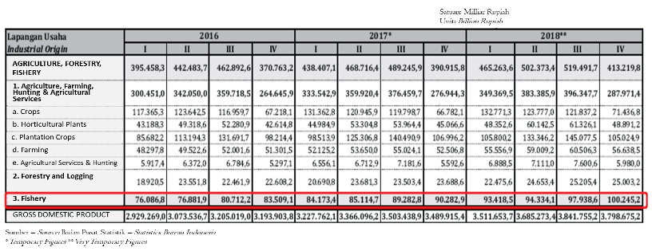
Tabel 1: The Gross Domestic Bruto (GDP) at Constant Prices 2010, 2016-2018

The first of the seventeen (17) targets in the Sustainable Development Goals (SDGs) launched by the United Nations (UN) since 2015 is "No Poverty". Indonesia as one of the 193 countries that adopted the SDG has the responsibility to achieve these goals together. Not only by the Indonesian government, but the role, participation and cooperation of the private sector, academia, philanthropy and national components are required.

Figure 1. Sustainable Development Goals
In the event of efforts to achieve the first target, it is necessary to pay close attention and anticipate the role of income inequality in economic growth as one of the risks of "Rising Income and Wealth Disparity" which has received considerable attention among researchers, academics, policy makers and economists. Among the researchers is Simon Kuznets, a Nobel prize winner, with his theory of the effects of economic growth in income distribution. According to Kuznets’ observations, in poor countries economic growth adds to income disparities between rich and poor people. In a prosperous country, economic growth narrows the difference. In addition, Kuznets analyzes and quantifies the recurring nature of production and prices over a period of 15-20 years and argues that as the economy develops, the natural cycle of economic inequality occurs, represented by an inverted U-shape curve called the Kuznets curve.
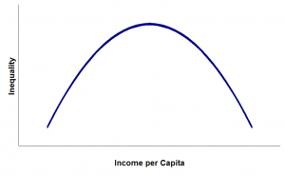
Figure 2: Kuznets Curve

The Kuznets curve above illustrates that as the economy develops, inequality first increases, then decreases after a certain level of average income has been reached. In the early development, investment opportunities for those who already had wealth doubled so that the capital owner could accumulate wealth. At the same time there was a wave of cheap rural labor into developing cities, which reduced wages. Therefore, in the initial development, inequality has increased. When the economy matures, there is democratization and various redistribution mechanisms such as social welfare programs. According to Kuznets, countries returned to lower levels of inequality.
Therefore, efforts are needed to prosper fishermen from all categories in order to avoid urbanization and prosper the lives of fishermen in their habitat (Figure 3). The Indonesian Institute of Sciences (LIPI) through the Oceanographic Research Center said a rough estimate of the potential value of the Indonesian sea as of March 2019 was valued at 1.772 trillion taken from the raw value of Indonesia's potential wealth. That is, not including subjective calculations that make the value of wealth to be different in each region. At 1.772 trillion, 312 trillion is from fisheries, 45 trillion from coral reefs, 21 trillion from mangroves, 4 trillion from seagrasses, 560 trillion is the potential of coastal wealth, 400 trillion biotechnology, 20 trillion marine tourism, 210 trillion petroleum, and 200 trillion from sea transportation.

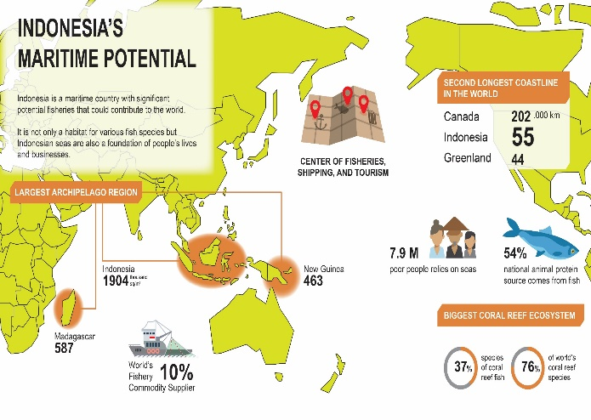
Figure 3: The Potential Value of the Indonesian Sea

The main stakeholder in the capture fisheries industry is subsistence fishermen located in the coastal area, which is the largest area in Indonesia, as the country with the longest coastal line in the world. As an archipelagic country, of course the fishermen on the coast are the vanguard of supporting components of national security that need to have independence in supporting their lives. This definition of a broad coastal population is only focused on groups of fishermen, fish farmers, fish traders and processors. This group manages and utilizes fish resources through fishing and cultivation activities. This group is also the most widely spread in coastal areas throughout Indonesia, on the coast of large and small islands. Generally, these coastal fishing communities are small and medium scale entrepreneurs. Many of them fish for subsistence, doing business and economic activities to support their own families, on a very small scale so that the results are only enough to meet short-term needs. The number of coastal fishermen can be seen in Figure 4, where the number is around 2.65 million, which means that if the average fisherman has 2 dependents, the number will be around 7.9-8 million people.

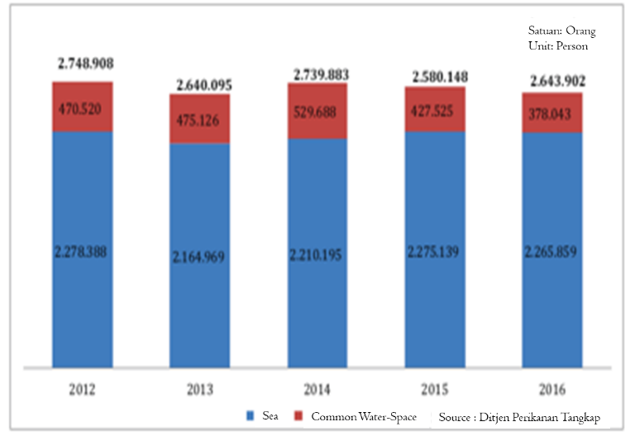
Figure 4. Number of Fishermen in Indonesia (Source: GOI Marine and Fisheries Ministry 2012-2016)

When linked to data on the number of fishermen in Indonesia, there are around 7.9 million poor people who depend on marine commodities.

SOLUTION
One of the fastest solutions that can support the productivity of fishermen is the manufacture and procurement of fishing vessels using ferrocement. Ferrocement has been introduced as an engineering material since 1942 by the United State Navy in Vietnam, since then is used as material for construction of ship hull. Ferrocement as a ship construction material has also been received and received recognition from the Lloyd’s Register of shipping, the Bureau of Veritas, the United Kingdom White Fish Authority and the UN-FAO (Food and Agriculture Organization of the United Nations).

Based on experience in various regions and in terms of economies of scale, hulls made from Ferrocement can provide satisfactory services if built using materials that are in accordance with approved standards for steel, cement and sand in addition to qualified labor. It must be remembered that the construction of ferrocement vessels under the reference is very different from the conventional Reinforced Cement Concrete (RCC) which is the standard of civil engineer.

The basic principle in shipbuilding is following the Archimedes' law and "Buoyancy" where an object that floats in liquid will have a positive buoyancy, which means that the amount of water displaced by a heavy object is greater than the object itself. Boats that replace larger water weights are partly due to size and shape. Most of the boat's interior is air, which is very light. This explains why large ships can float: as long as the displaced water weighs more than the vessels themselves, they will not sink, regardless of what material is used.

Ferrocement shipbuilding is following the above mentioned rules and uses techniques that manufacture ship walls with very thin thickness, 1" or 18 mm to 25 mm, with a very strong reinforced concrete slab and four layers of galvanized iron wire mesh firmly mounted on both sides of the steel frame which forms a mold consisting of vertical and horizontal bars (thickness 6.2 mm and spaced 3 "x 2" (75 mm x 50 mm). Mortar is a mixture of high-quality cement and sand that after mixing with water by stirring to get a homogeneous mass, to ensure there is no porosity wherever a vibrator is used through a dense mesh layer.

Curing process requires a blanket. The final structure after curing must be completely waterproof. The steel content will work about a quarter of mortar while the density of a mortar is four times the volume of steel. The mixture ratio uses K350 where 1 portion is for mortar, 1.5 portions for sand and 2 portions for gravel. The outer hull will be coated with suitable and weather-resistant paint before being launched as a protective measure against water seepage and violations / accidents at sea.

The advantage of a Ferrocement vessel is the ease and simplicity of its construction along with the ease of maintenance and repair. Ferrocement vessels are ideal for use in tropical climates because the hull can be perfectly finished so it is almost indistinguishable from ships with other materials, (FAO). Finished concrete hulls do not absorb water and therefore do not exist risk or contamination. Compared to traditional wooden trawlers of the same size, ferrocement vessels are more stable, have more vessel space, greater durability, can carry stronger hoists, bigger isolated fish hatches, a larger engine and more efficient deck arrangement for fishing operations.

Ferrocement ship structure has excellent insulation which as a result there is little or no risk of condensation on the concrete hull. It is interesting to note that the Ferrocement structure becomes stronger with increasing age especially under constant contact with sea water; good for producing low frequency vibrations and unlike FRP, ferrocement is very hard and resistant to abrasion. Ferrocement ships have the longest life in water because reports prove that experimental boats existing today were built almost 100 years ago.

Based on theoretical calculations and with the limited experience available with this new material, the cost of producing ferrocement vessels can be much cheaper than conventional wood hulls. Simple construction procedures that require simple tools and a regular skilled workforce. If the supply of steel bars is unimpeded and unrestricted and good quality cement is guaranteed this new solution will catch up with the market in the near future because of its low manufacturing costs, high strength and durability. As an illustration, the construction of a 5GT class Ferrocement ship in Tanjung Burung (Collaboration with PT Wahana Indra Sentosa), Banten with dimensions of 10.3m x 3m x 1.5 m was completed in 28 days.

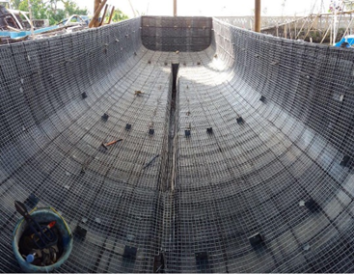
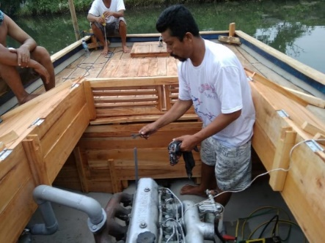

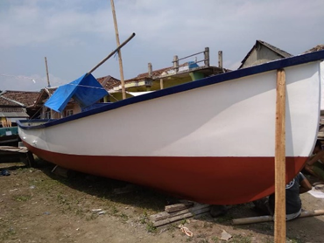
Figure 5: Construction of a 5 GT Ferrocement Ship in Tanjung Burung, Banten

In accordance with the needs of coastal fishermen in Indonesia that are spread along large and small islands, this technology is suitable to be developed in remote areas because all materials are easy to find and construction does not require skilled labor. From an economic perspective maintenance costs are also low. The advantage of ferrocement as a construction material, besides the high cracking strength compared to ordinary reinforced concrete, is greater ductility and can be produced with thinner sections (20mm-35mm) only.

In 1976 this technology was proven in making platform-threshold made of precast/ prestressed concrete which was built in Washington (USA) and then pulled into the Java Sea. The structure with a length of 140 m and a width of 41.5 m, and the depth of the ship (drought) 17.1 m (461 feet x 136 feet x 57 feet), was designed by ABAM Engineers, Inc., and was built by Concrete Technology Corporation. The ship, which was designed as a permanent berthing facility for LPG storage and processing.

In May 2017 the Southeast Asia Largest Floating Concrete Dock was completed in Batam Island to fulfill orders from Hawaii, United States. The floating dock or drydock weighs 15,500 metric tons with a length of 138 meters, width of 46 meters and height of 15 meters. The upper wall uses a temporary iron base or floor of cement. The construction of the ship or concrete dock was carried out by more than 500 workers from Batam who were assisted by a team of consultants and international engineers for 13 months and planned to be used as a floating dock that could contain two medium-sized ships. The choice of the floating dock solution with this concrete structure is more durable and economical and the concrete structure is significantly more stable to operate and weather resistant.
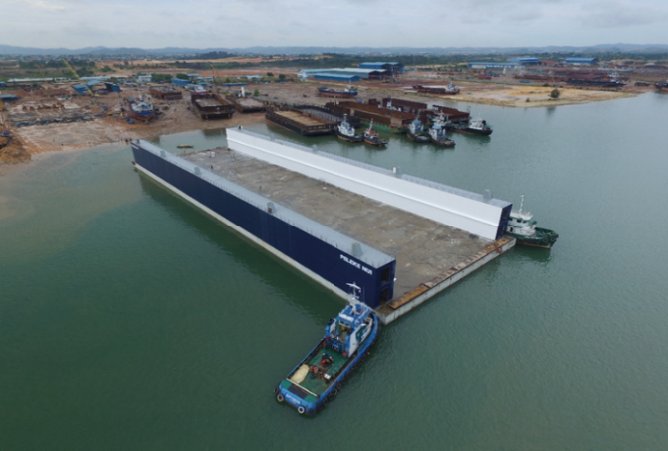
Figure 6: The Southeast Asia Largest Floating Concrete Dock
Specific requirements for the construction of Ferrocement ships are referring to FAO for use of materials, shipbuilding designs that need extra attention such as the weight of the ships, the way of construction up to the final installation stage. The ship designer must really master the techniques that can be used, especially because of the shipyards’ limitations. The designer also needs to have the level of control and / or authority needed to ensure that construction follows calculations, scantling and weighting that is considered during the design phase. This will save a lot of time from possible misunderstandings and hence costs if the potential problems can be solved at an early stage.
Designers and builders must be fully aware of the need for accurate information from the very beginning in the hull ship construction phase to produce efficient Ferrocement hulls. Information such as vessel tube details and stern gear details including Plummer blocks, boat tube details and steering gear details, boat engine and engine bed details, leather installation schedule, scupper schedule, details on all hull networks, hull and service pipe requirements, steering pipes, water and fuel tank seats and things that affect the shape of the floor and adjacent nets for installation, ferrocement beam rack details (if needed), bulk-head details including all required openings, etc..
Ferrocement also has weaknesses, where the boat’s outer cement skin can be a place where marine animals (e.g. barnacles) perch. The presence of sea animals that accumulates on the surface of the ship's bottom wall, can reduce the performance of the ship. However, PVC based protective paint can be used to overcome this.
CONCLUSION
Utilization of fishing boat technology with relatively inexpensive ferrocement material for fishermen can encourage increased productivity of fishermen, mastering ferrocement fishing boat technology opens opportunities for fishermen to catch fish in more distant waters and obtain a surplus from their catch because they have greater capture power. The poverty alleviation goals contained in the Sustainable Development Goals can be realized and have an impact on economic equality and safeguarding Indonesia's sovereign territory.

REFERENCES
- Marine & Fisheries in Figure 2018, Ministry of Fisheries and Sea Affair Data
- https://en.wikipedia.org/wiki/Sustainable_Development_Goals
- https://sevenpillarsinstitute.org/causes-economic-inequality
- https://www.gatra.com/detail/news/411647/ekonomi/lipi-potensi-kekayaan-laut-indonesia-setara-93-pemasukan-apbn-2018
- Morgan, R.G., “History of and Experience with Concrete Ships,” Conference on Concrete Ships and Floating Structures, Berkeley, California, Sept. 1975
- https://batam.tribunnews.com/2017/05/03/keren-dok-apung-beton-terbesar-si-asia-tenggara-dibuat-pekerja-batam-dikirim-ke-amerika
- http://www.fao.org/3/v9468e/v9468e0c.html
- Harrington, K.E., and Harrison, R., “Survey of the operational experience achieved with Prestressed Concrete/ Reinforced Concrete and Ferrocement Barge and Pontoon Hull Since 1950,’ Sunderland Polytechnic, March 1981.

Marine & Fisheries in Figure 2018, Ministry of Fisheries and Sea Affair Data
Ibid
https://www.un.org/development/desa/disabilities/envision2030.html
https://sevenpillarsinstitute.org/causes-economic-inequality, diunduh tanggal 23 Desember 2019 pukul 05.00
https://www.gatra.com/detail/news/411647/ekonomi/lipi-potensi-kekayaan-laut-indonesia-setara-93-pemasukan-apbn-2018
Marine & Fisheries in Figure 2018, Ministry of Fisheries and Sea Affair Data
ibid
Morgan, R.G., “History of and Experience with Concrete Ships,” Conference on Concrete Ships and Floating Structures, Berkeley, California, Sept. 1975
Ibid
https://batam.tribunnews.com/2017/05/03/keren-dok-apung-beton-terbesar-si-asia-tenggara-dibuat-pekerja-batam-dikirim-ke-amerika
http://www.fao.org/3/v9468e/v9468e0c.html
Harrington, K.E., and Harrison, R., “Survey of the operational experience achieved with Prestressed Concrete/ Reinforced Concrete and Ferrocement Barge and Pontoon Hull Since 1950,’ Sunderland Polytechnic, March 1981.

