BIBLIOMETRIC ANALYSIS ON SOCIAL ENTREPRENEURSHIP SPECIALIZED JOURNALS
Yusuf ISKANDAR¹, Joeliaty JOELIATY², Umi KALTUM³, Hilmiana HILMIANA⁴
Faculty of Economics and Business, Universitas Padjadjaran, Bandung, Indonesia
E-mails: ¹yiskandar.indonesia@gmail.com (corresponding author); ²joeliaty@unpad.ac.id; ³umi.kaltum@unpad.ac.id; ⁴hilmiana@unpad.ac.id
Received day month year; accepted date
Abstract. The topics of social entrepreneurship have increased considerably time by time. Social entrepreneurship becomes an engaging, specific theme in the field of entrepreneurship research. The purpose of this paper is to analyze how are social entrepreneurship articles classified. Then, to know what is the trend of social entrepreneurship research, to know which research topics are the subject of more publications, and to analyze what are future social entrepreneurship topics that provide opportunities for further investigation. There are two journals from leading publishers that specifically offer a publishing platform for the issue of social entrepreneurship. There are many articles in these two journals that can specifically give us information about the development of this entrepreneurial topic. We have reviewed this database and attempted to classify materials using VOSviewer software. There are several article groupings into sub-topic sections.
Keywords: social entrepreneurship, bibliometric analysis, publish or perish, mendeley, vosviewer.
JEL Classification: L31, C40.

Introduction
Social entrepreneurship has developed into something interesting in the twenty-first century (Mair 2010). This phenomenon occurs because the main focus is not to optimize profits but also for community building (Ayob et al. 2014). Some experts such as (Dees 2007) and (Fowler 2000) argue that social entrepreneurship is suitable to be developed now and has a decisive role in solving social problems. Social entrepreneurship has become a new inspiration in developing paradigms related to non-governmental development organizations. (B. J. Boschee and Mcclurg 2003) see the potential of social entrepreneurship in producing something promising, especially in social issues such as increasing income in traditional business activities. One of the most famous people and one of the best examples of social entrepreneurship is the 2006 Nobel Peace Prize winner, Muhammad Yunus. He founded the highly successful Grameen Bank in Bangladesh to provide credit to the poor to help them move out of poverty.
Social entrepreneurship is a growing topic and is increasingly being studied by academics today (Rey-Martí, Ribeiro-Soriano, and Sánchez-García 2016). In fact, until now, there have been two journals explicitly dedicated to the topic of social entrepreneurship, namely the Journal of Social Entrepreneurship and the Social Enterprise Journal. The theme of social entrepreneurship is also commonly found in other entrepreneurial journals. Based on the results of previous studies, the literature on social entrepreneurship is considered to be in a challenging and developing way, where analysis of the status and legitimacy of the field still requires further study (Granados et al. 2011), (Rey-Martí, Ribeiro-Soriano, and Sánchez-García 2016), (Dionisio 2019). Researchers yet have not determined the amount or quality of research carried out in this field (Peredo and McLean 2006). Based on the statements of the previous researchers, it is necessary to have a recent study of the bibliometrics from the term of social entrepreneurship.
Social entrepreneurship has been the subject of discussion reviewed by previous researchers. Some academics such as (Gonçalves, Carrara, and Schmittel 2016), (Braga, Proença, and Ferreira 2014), and (Campos, Sanchis, and Ejarque 2019) have tried to discuss social entrepreneurship by doing a general review to be used as the scientific development of this topic. (Dionisio 2019) provides an overview of research on social entrepreneurship through a bibliometric study and the use of (Gartner 2016) framework to determine the evolution of social entrepreneurship. The study is based on all conceptual and research papers published in the Social Enterprise Journal from 2005 to 2017. (Rey-Martí, Ribeiro-Soriano, and Sánchez-García 2016) also made an overview of social entrepreneurship through bibliometric analysis using the article from the Web of Science database.
To the best of our knowledge, no bibliometric analysis of the social entrepreneurship topics has been conducted from the two journals indexed by Scopus specialized in social entrepreneurship research. Those two social entrepreneurship specialized journals are the Journal of Social Entrepreneurship and Social Enterprise Journal. The purpose of this paper is to answer the following questions (1) how are social entrepreneurship articles classified?, (2) what is the trend of social entrepreneurship research?, (3) which research topics are the subject of more publications?, and the (4) what are future social entrepreneurship topics that provide opportunities for further research?.
This paper was prepared to start with a literature review of the term social entrepreneurship based on the results of previous studies. Besides, the research objectives are also presented in Section 1. In Section 2, the definition of social entrepreneurship and the existing review of the term social entrepreneurship is explained. The methodology used to carry out bibliometric analysis, including the method steps related to the use of databases from the three journals in Section 3. Section 4 presents the results using VOSviewer. Research recommendations, conclusions, and limitations appear in Section 5.

1. Social entrepreneurship
The social dimension of entrepreneurship was developed by (Shapero and Sokol 2009) who at that time had not yet found a satisfying discovery. Furthermore, (Dees 2007) revealed that at that time, the term social entrepreneurship was considered new, but the practice of social entrepreneurship was not new. The statement is also in line with (J. Boschee 1998). (Borgaza, Depredi, and Galera 2012) revealed that social entrepreneurship is an approach of non-profit businesses and social economy, and is another form of entrepreneurship in general.
(Dees 2007) revealed that there are fundamental differences between social entrepreneurs and businesses. In social entrepreneurship, the social mission is explicit and central. This opinion is also in line with the statement put forward by (Martin and Osberg 2007) which states that social entrepreneurs uphold social aspects higher than usual. The ﬁeld of social entrepreneurship has thus become a large tent (Martin and Osberg 2007). However, the definitions of social enterprise and social entrepreneurship seem to have different versions due to diverse academic backgrounds, geographic locations, and the economic developmental context of the countries (Defourny and Nyssens 2012), (Granados et al. 2011).
For the purpose of this study, the authors have developed the definition by following the explanations by (Granados et al. 2011) and (Stephan and Drencheva 2017) that social entrepreneurship is a business activity carried out by a person or group of people who are driven by a range of motivations and values which include but are not limited to prosocial concerns with innovative ways through enterprise operations, which could be either a social enterprise, non-profit, private or public institution. Previous researchers have done several bibliometric analyzes in Table 1, detailed related previous research, including the sources of database and their main findings.
Table 1. Several bibliometric analyzes that have been done by previous researchers on the topic of social entrepreneurship
Author(s) & Year | Number of Documents Analyzed | Sources | Findings
(Rey-Martí, Ribeiro-Soriano, and Sánchez-García 2016) | 2984 | Web of Science online databases | The area with the most published documents is business economics. The term social entrepreneurship ﬁrst appeared in 1964, but only after 2003, the concept begins to attract researchers' attention, and the number of publications begins to increase year on year. The country responsible for most social entrepreneurship research is the United States. The journal that has published the most on social entrepreneurship research is the Journal of Bussiness Venturing, which has an impact factor of 3.265. The most proliﬁc social entrepreneurship author is Anderson AR with 12 documents and 539 citations).
Ferreira et al. (2016) | 204 | Web of Science online databases | The results enable the aggregation of state of the art in social entrepreneurship across four perspectives. Those are social value, well-being embeddedness, internationalization, and institutional.
(Kumar, Balaji, and Narayanamurthy 2019) | 1296 | Web of Science online databases | The findings of this paper are (1) identifying key scholarly contributions in the field and the linkages among them, (2) tracing the evolution of the field over time, (3) analyzing the social entrepreneurship field.
(Campos, Sanchis, and Ejarque 2019) | 124 | EBSCO Business Source Premier, Emerald, JSTOR, Science Direct, Springer, and Wiley Online. | The authors find the business model derived from the CG matrix and ECG model, specially appropriated for the promotion of SE because it is based on the three dimensions of sustainability: economic, social, and environmental. The social and ethical management on which the ECG model bases its relationships with stakeholders provides it with the essential features of SE. Consequently, from a theoretical point of view, it is possible to find multiple overlaps and connections between the ECG model and SE that can be reinforced.
(Farinha et al. 2020) | 2695 | Web of Science online database | The main conclusion is that, from the analysis, we can see that scientific production in this field of knowledge has intensified in recent years. Still, the centrality and the search density undergo significant changes. New paths for future research are outlined. In summary, from period 1 to period 3, we observe that the theme "social innovation" remains with a focus of study, as well as the theme "social entrepreneurship," although now with less transversality and development. However, the issue of "sustainability" is now the subject of study within the areas "social entrepreneurship," "social innovation," "innovation," and "case study." The same evolutionary path suffered the theme "social enterprise."
(Dionisio 2019) | 154 | Social enterprise journal | The bibliometric analysis highlighted the tendency towards integration with a signiﬁcant presence of co-operation between authors and institutions, where 70 percent of articles produced by the most proliﬁc authors were written in co-authorship and 30 percent of them by more than four different authors, what enriches the development of the ﬁeld. Authorship pattern also shows that there is a high level of internalization of the ﬁeld, with 289 different authors, from institutions from 30 different countries writing articles about 40 countries on all ﬁve continents. The research strategy most employed was qualitative through the use of case studies.

2. Methodology: a bibliometric analysis
The purpose of this paper is to analyze how are social entrepreneurship articles classified. Then, to know what is the trend of social entrepreneurship research, to know which research topics are the subject of more publications, and to analyze what are future social entrepreneurship topics that provide opportunities for further investigation.

2.1. Search for specific journals on the topic of social entrepreneurship
A bibliometric review is generally used in scientific disciplines and focuses on a quantitative study of journal papers, books, or other types of written communication (Heersmink et al. 2011). Work begins with searching in Google databases related to journals that specifically address the topic of social entrepreneurship. Several journals specifically address this topic, and there is the Journal of Social Entrepreneurship (JSE), Social Enterprise Journal (SEJ), Journal of Global Business and Social Entrepreneurship (GBSE), and International Journal of Social Entrepreneurship and Innovations (IJSEI).

2.2. Journal reputation
At this stage, journals that have good standing have been selected and are still in progress today. Table 2 shows the results of the journal screening.
Table 2. Profile of a journal with a special topic on social entrepreneurship
Penilaian | JSE | SEJ | GBSE | IJSEI
Publisher | Taylor & Francis | Emerald | GBSE Global | Inderscience
First published | 2010 | 2005 | 2015 | 2011
Last published | 2020 (on going) | 2020 (on going) | 2020 (on going) | 2018
Scopus Indexed | Yes | Yes | No | No.
Web of Science Indexed | No | No | No | No
Impact factor by SJR | 0.46 | N/A | N/A | N/A

Based on Table 2, there are only two journals indexed by Scopus, namely JSE and SEJ. JSE has the best reputation among the four journals because it has a high impact factor from SJR to be classified in Q2. However, SEJ is also essential to be analyzed because it is the first journal specifically on social entrepreneurship.

2.3. Journal metrics information
This section describes explicitly the profiles and metrics of the two selected journals, namely SEJ and JSE. Table 3 shows some important things to know from the two chosen journals. This metric information is obtained from metadata information using the Publish or Perish (PoP) application on May 18 2020.
Table 3. Metrics information of selected journals
Metrics data | JSE | SEJ
Publication years | 2010-2020 | 2005-2020
Citation years | 10 | 15
Papers | 205 | 248
Citations | 5812 | 8763
Cites/year | 581.2 | 584.2
Cites/paper | 28.63 | 36.06
Authors/paper | 2.26 | 2.12
h-index | 36 | 50
g-index | 71 | 88
hI,norm | 27 | 37
hI,annual | 2.7 | 2.47

2.4. Reference management
After all, articles have been downloaded from the two journal websites, and the next step is tidying references using the Mendeley application. References are needed to ensure that the metadata for each article is complete, such as information about the author, keywords, abstracts, and other information.

2.5. Bibliometric analysis
After all of the article's metadata is confirmed to be complete, the next step is to conduct a bibliometric analysis. The application used in analyzing bibliometrics in this article is VosViewer.

3. Results and Discussion
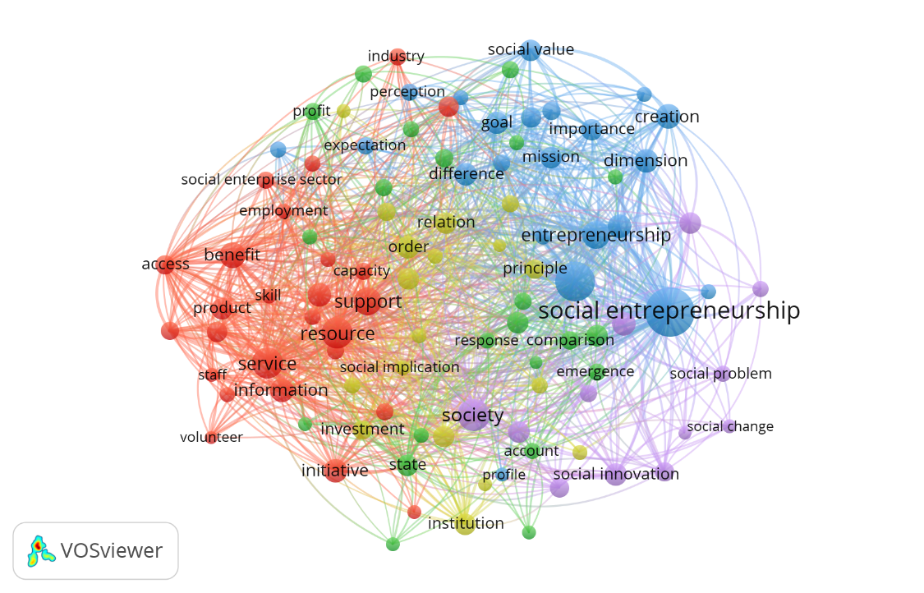
To answer the first purpose of this paper about how are social entrepreneurship articles classified, in JSE and SEJ using VosViewer software, through creating a map based on text data using the title and abstract fields, with the binary counting method there are 8594 terms found. With a minimum number of occurrences of a term of 10 times, 234 thresholds were found. However, for each of the 234 terms, a relevance score will be calculated. Based on this score, the most relevant terms will be selected automatically by default as much as 60%, so we get the 140 most appropriate words. However, the verification process still has to be done manually by eliminating unrelated words, such as editorial, sample, abstract, and others. Thus, the total words that can be included in making a map are 100 words.

Figure 1. Network visualization map of keywords

Based on Figure 1, there are several clusters characterized by blue, purple, yellow, red, and green. Based on the total articles from JSE and SEJ, several words in the cluster appear most often. These clusters are an indication that, to date, there are five classifications of articles published by JSE and SEJ. In more detail can be seen through table 4.
Table 4. Clusters and keywords therein
Cluster | Total items | Most frequent keywords (occurrences) | Keywords
1 | 26 | resource (52), service (52), support (44) | ability, access, benefit, capacity, company, condition, employee, employment, England, income, industry, information, initiatives, lesson, manager, member, person, product, resource, sense, service, skill, social enterprise sector, staff, support, volunteer
2 | 22 | state (28), environment (28), action (27) | account, action, application, attempt, Australia, comparison, complexity, cooperative, emergence, environment, evolution, lack, leader, limitation, performance, profit, response, ses, social economy, social enterprise model, social enterprises, state
3 | 22 | social entrepreneurship (121), entrepreneur (80), entrepreneurship (43) | assumption, creation, difference, dimension, diversity, effect, entrepreneur, entrepreneurship, expectation, extent, goal, importance, light, mission, motivation, operation, perception, profile, social capital, social entrepreneurship, social mission, social value
4 | 18 | policymaker (31), institution (27), governance (26), government (26) | difficulty, discourse, effectiveness, governance, government, identity, institution, investment, legitimacy, mechanism, order, policymaker, principle, relation, risk, social implication, variety
5 | 12 | society (55), innovation (31), social innovation (30) | change, innovation, phenomenon, region, social, social change, social innovation, social problem, social venture, society, solution, venture

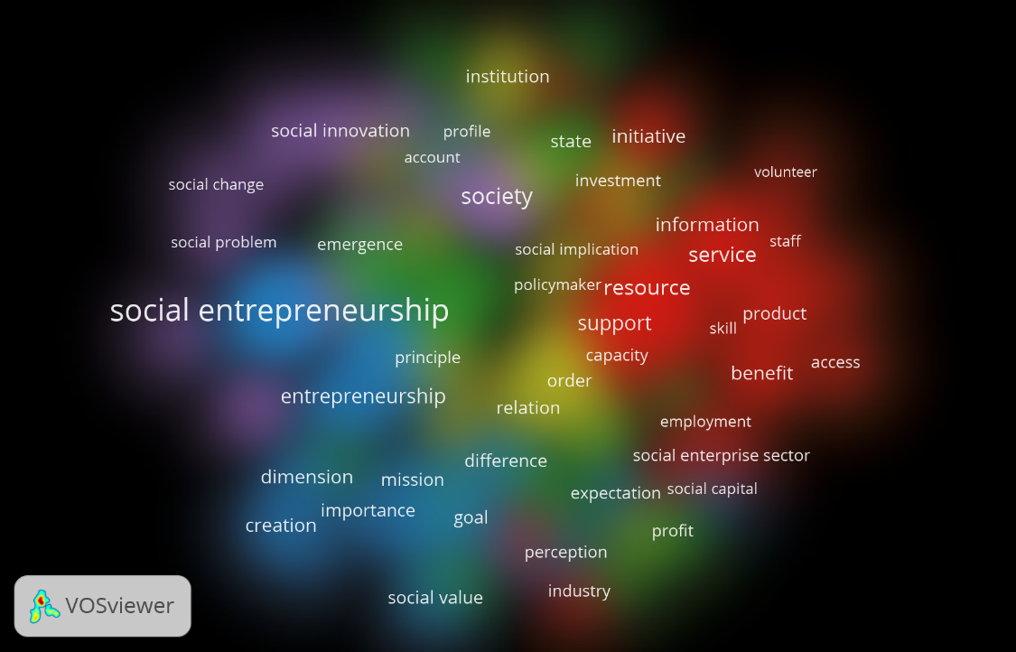
Then, to answer what is the trend of social entrepreneurship research, we can see the answer actually from the cluster itself. Figure 2 shows the density visualization of articles published by JSE and SEJ. Cluster 1, with the word resource and service being the words that appear most often.

Figure 2. Density visualization map of keywords

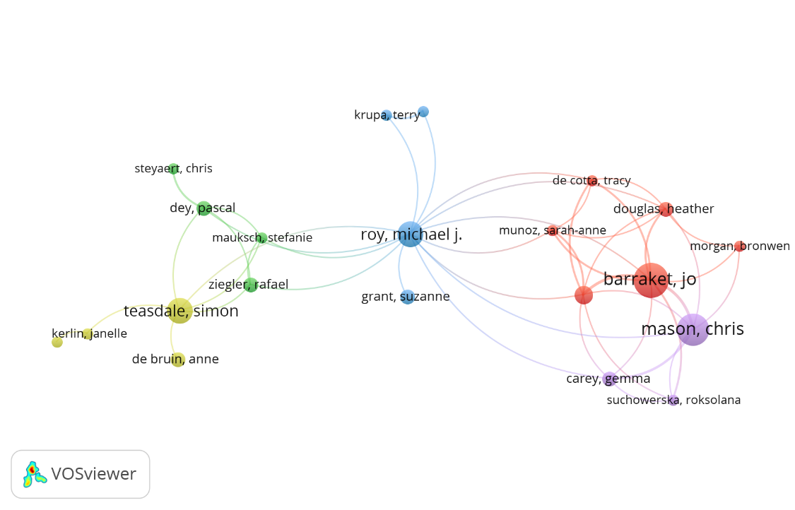
There is a cluster of the results of this mapping that appears at least in the keyword, namely cluster 5. This cluster covers topics about innovation and social innovation. Also, in each cluster, some words rarely appear in keywords, such as social entrepreneurial intention, social entrepreneurship model, or those related to institutions and government. The meaning is, there are still research gaps that are very likely to become a trend in the future, which, of course, is adapted to current world conditions and the future. From the researcher's side, there are also five clusters, as presented in Figure 3.

Figure 3. Network visualization map of authors

Based on Figure 3, it can be seen that there are five big names from each cluster that are marked with large dots in each cluster. In the picture, only writers who are related in their publications are shown. However, if the authorship of the authorship is eliminated, the writer with the most significant point is Alex Nicholls with 17 documents and the majority in JSE, then Jo Barraket both in JSE and SEJ with nine papers and Chris Mason with eight articles, the majority of which are in SEJ. In Table 5, it is known that the documents from the two most cited journals, along with other detailed elements, were calculated on May 18 2020.
Table 5. The top ten cited documents in JSE and SEJ
JSE |  |  | SEJ
Citations | Authors and year | Title | Citations | Authors and year | Title
1306 | (Defourny and Nyssens 2010) | Conceptions of social enterprise and social entrepreneurship in Europe and the United States: convergences and divergences | 901 | (Defourny and Nyssens 2008) | Social enterprise in Europe: recent trends and developments
216 | (Nicholls 2010) | The institutionalization of social investment: the interplay of investment logics and investor rationalities | 520 | (Haugh 2012) | A research agenda for social entrepreneurship
176 | (Germak and Robinson 2014) | Exploring the motivation of nascent social entrepreneurs | 451 | (Galera and Borzaga 2009) | Social enterprise: An international overview of its conceptual evolution and legal implementation
169 | (Bloom and Smith 2010) | Identifying the drivers of social entrepreneurial impact: theoretical development and an exploratory empirical test of SCALERS | 259 | (Peattie and Morley 2008) | Eight paradoxes of the social enterprise research agenda
158 | (Hill, Kothari, and Shea 2010) | Patterns of meaning in the social entrepreneurship literature: a research platform | 223 | (Defourny and Kim 2011) | Emerging models of social enterprise in Eastern Asia: a cross‐country analysis
130 | (Urbano, Toledano, and Soriano 2010) | Analyzing social entrepreneurship from an institutional perspective: evidence from Spain | 187 | (Bull 2007) | "Balance": the development of a social enterprise business performance analysis tool
116 | (Teasdale, Lyon, and Baldock 2013) | Playing with numbers: a methodological critique of the social enterprise growth myth | 177 | (Granados et al. 2011) | Social enterprise and social entrepreneurship research and theory: A bibliometric analysis from 1991 to 2010
115 | (Ormiston et al. 2015) | Understanding value creation in social entrepreneurship: the importance of aligning mission, strategy and impact measurement | 171 | (Hynes 2009) | Growing the social enterprise – issues and challenges
105 | (Frumkin and Keating 2011) | Diversification reconsidered: the risks and rewards of revenue concentration | 168 | (Thompson 2008) | Social enterprise and social entrepreneurship: where have we reached? A summary of issues and discussion points
100 | (Florin and Schmidt 2011) | Creating shared value in the hybrid venture arena: a business model innovation perspective | 166 | (Jiao 2011) | A conceptual model for social entrepreneurship directed toward social impact on society

It can be seen that in the period 2008-2011 were the years in which the document on social entrepreneurship was the most explicitly cited. The most recent materials tend not to be cited much, except the authors who have researched this field before, and they are quite well-known. Then, to see which research topics are the subject of more publications, we can see it through Table 6.
Table 6. The 15 most and fewer occurrences terms in JSE and SEJ
Most occurrences |  | Fewer occurrences
Occurrences | Term | Occurrences | Term
185 | Entrepreneur | 10 | Commercial venture
135 | Framework | 11 | Social impact measurement
101 | Sector | 11 | Women social entrepreneur
87 | Social innovation | 12 | Interaction
74 | Service | 12 | Marketing
70 | Strategy | 12 | Civil society
56 | Effect | 12 | Social support
54 | Person | 12 | Work integration of social enterprise
54 | Policy | 12 | Consumer
52 | Outcome | 12 | Mental illness
50 | Benefit | 13 | Leadership
49 | Motivation | 13 | NGO
49 | Influence | 14 | Policymaker
45 | Contribution | 14 | Social network
44 | Social value | 15 | Social implication

In addition to explaining which subjects appear most frequently in publications, Table 6 also describes the last purpose of this paper, namely, what are future social entrepreneurship topics that provide opportunities for further research. Issues that can be an opportunity to be explored in more detail are more specific and lead to the implications or measurements of the social enterprise that has been run. Topics such as marketing and consumers have also not been much researched on JSE and SEJ. While issues such as strategy, the influence of a variable on other variables, and social innovation have been studied quite a lot. Similarly, topics related to entrepreneurs themselves, such as their characteristics, intensities, also quite a lot emerged.

Conclusions
The current study reviewed a set of 453 articles with themes related to social entrepreneurship. The articles were collected from the Journal of Social Entrepreneurship and Social Enterprise Journal. In the context of this study, we conclude that JSE and SEJ have a more significant impact in the field of social entrepreneurship nowadays because they both specialized in social entrepreneurship topics. Social entrepreneurship articles classified into five clusters. The trend of social entrepreneurship research is more on the business side and entrepreneurs. There are several topics that often appear in publications, such as social innovation, strategy, and the influence of one variable on another. Topics that have rarely appeared in JSE and SEJ are commercial ventures, social impact measurement, and women social entrepreneurs.
The current study has at least two limitations. First, the study is mainly only based on JSE and SEJ. Second, although this study used formal tools (PoP software, the VOSviewer, and Mendeley), subjective assessments by authors exist and could still lead to the introduction of errors. Future studies should use a larger sample size by involving other journals, although not indexed by Scopus. In addition, a comparison of the results of an analysis using different bibliometric analysis software (such as BibExcel and HistCite) is recommended.

References™
Ayob, Noorseha, Ching Seng Yap, Dewi Amat Sapuan, and Md Zabid Abdul Rashid. 2014. "Social Entrepreneurial Intention among Business Undergraduates: An Emerging Economy Perspective." Gadjah Mada International Journal of Business 15(3): 249. https://jurnal.ugm.ac.id/gamaijb/article/view/5470 (April 12, 2020).
Bloom, Paul N., and Brett R. Smith. 2010. "Identifying the Drivers of Social Entrepreneurial Impact: Theoretical Development and an Exploratory Empirical Test of SCALERS." Journal of Social Entrepreneurship 1(1): 126–45.
Borgaza, Carlo, Sara Depredi, and Giulia Galera. 2012. "Interpreting Social Enterprises." Revista de Administração 47(3): 398–409. http://dx.doi.org/10.5700/rausp1046.
Boschee, By Jerr, and Jim Mcclurg. 2003. "Toward a Better Understanding of Social Entrepreneurship: Some Important Distinctions." Chief Executive: 1–7. http://www.se-alliance.org/better_understanding.pdf.
Boschee, Jerr. 1998. "Merging Mission and Money: A Board Member's Guide to Social Entrepreneurship." The National Center for Nonprofit Boards: 1–12. http://www.socialent.org/pdfs/MergingMission.pdf.
Braga, J.C., T. Proença, and M.R. Ferreira. 2014. "Motivations for Social Entrepreneurship – Evidences from Portugal." Tékhne 12(October 2018): 11–21. http://dx.doi.org/10.1016/j.tekhne.2015.01.002.
Bull, Mike. 2007. "‘Balance’: The Development of a Social Enterprise Business Performance Analysis Tool.” Social Enterprise Journal 3(1): 49–66.
Campos, Vanessa, Joan Ramon Sanchis, and Ana Ejarque. 2019. “Social Entrepreneurship and Economy for the Common Good: Study of Their Relationship through a Bibliometric Analysis.” International Journal of Entrepreneurship and Innovation.
Dees, J. Gregory. 2007. “Taking Social Entrepreneurship Seriously.” Society 44(3): 24–31.
Defourny, Jacques, and Shin‐Yang Kim. 2011. “Emerging Models of Social Enterprise in Eastern Asia: A Cross‐country Analysis.” Social Enterprise Journal 7(1): 86–111.
Defourny, Jacques, and Marthe Nyssens. 2008. “Social Enterprise in Europe: Recent Trends and Developments.” Social Enterprise Journal 4(3): 202–28.
———. 2010. “Conceptions of Social Enterprise and Social Entrepreneurship in Europe and the United States: Convergences and Divergences.” Journal of Social Entrepreneurship 1(1): 32–53.
———. 2012. “EMES Working Papers Series The EMES Approach of Social Enterprise in a Comparative Perspective.” (12): 44.
Dionisio, Marcelo. 2019. “The Evolution of Social Entrepreneurship Research: A Bibliometric Analysis.” Social Enterprise Journal 15(1): 22–45.
Farinha, Luís, João Renato Sebastião, Carlos Sampaio, and João Lopes. 2020. “Social Innovation and Social Entrepreneurship : Discovering Origins , Exploring Current and Future Trends.” International Review on Public and Nonprofit Marketing 17: 77–96.
Florin, Juan, and Elizabeth Schmidt. 2011. “Creating Shared Value in the Hybrid Venture Arena: A Business Model Innovation Perspective.” Journal of Social Entrepreneurship 2(2): 165–97.
Fowler, Alan. 2000. “NGDOS as a Moment in History: Beyond Aid to Social Entrepreneurship or Civic Innovation?” Third World Quarterly 21(4): 637–54.
Frumkin, Peter, and Elizabeth K. Keating. 2011. “Diversification Reconsidered: The Risks and Rewards of Revenue Concentration.” Journal of Social Entrepreneurship 2(2): 151–64.
Galera, Giulia, and Carlo Borzaga. 2009. “Social Enterprise: An International Overview of Its Conceptual Evolution and Legal Implementation.” Social Enterprise Journal 5(3): 210–28.
Gartner, William B. 2016. “A Conceptual Framework for Describing the Phenomenon of New Venture Creation.” Entrepreneurship as Organizing: Selected Papers of William B. Gartner 10(4): 1–11.
Germak, Andrew J., and Jeffrey A. Robinson. 2014. “Exploring the Motivation of Nascent Social Entrepreneurs.” Journal of Social Entrepreneurship 5(1): 5–21. http://dx.doi.org/10.1080/19420676.2013.820781.
Gonçalves, Claudinei Pereira, Kester Carrara, and Richardson Moro Schmittel. 2016. “The Phenomenon of Social Enterprises: Are We Keeping Watch on This Cultural Practice?” Voluntas 27(4): 1585–1610.
Granados, Maria L., Vlatka Hlupic, Elayne Coakes, and Souad Mohamed. 2011. “Social Enterprise and Social Entrepreneurship Research and Theory.” Social Enterprise Journal 7(3): 198–218.
Haugh, Helen. 2012. “The Importance of Theory in Social Enterprise Research.” Social Enterprise Journal 8(1): 7–15.
Heersmink, Richard, Jeroen van den Hoven, Nees Jan van Eck, and Jan den van Berg. 2011. “Bibliometric Mapping of Computer and Information Ethics.” Ethics and Information Technology 13(3): 241–49.
Hill, T. L., Tanvi H. Kothari, and Matthew Shea. 2010. “Patterns of Meaning in the Social Entrepreneurship Literature: A Research Platform.” Journal of Social Entrepreneurship 1(1): 5–31.
Hynes, Briga. 2009. “Growing the Social Enterprise – Issues and Challenges.” Social Enterprise Journal 5(2): 114–25.
Jiao, Hao. 2011. “A Conceptual Model for Social Entrepreneurship Directed toward Social Impact on Society.” Social Enterprise Journal 7(2): 130–49.
Kumar, Pradeep, Hota Balaji, and Gopalakrishnan Narayanamurthy. 2019. “Mapping the Intellectual Structure of Social Entrepreneurship Research : A Citation / Co-Citation Analysis.” Journal of Business Ethics 0(0): 0. http://dx.doi.org/10.1007/s10551-019-04129-4.
Mair, Johanna. 2010. “Social Entrepreneurship: Taking Stock and Looking Ahead.” Handbook of Research on Social Entrepreneurship 3: 15–28.
Martin, Roger L., and Sally Osberg. 2007. “Social Entrepreneurship: The Case for Definition.” Stanford Social Innovation Review: 27–39.
Nicholls, Alex. 2010. 1 Journal of Social Entrepreneurship The Institutionalization of Social Investment: The Interplay of Investment Logics and Investor Rationalities.
Ormiston, Jarrod, Kylie Charlton, M. Scott Donald, and Richard G. Seymour. 2015. “Overcoming the Challenges of Impact Investing: Insights from Leading Investors.” Journal of Social Entrepreneurship 6(3): 352–78.
Peattie, Ken, and Adrian Morley. 2008. “Eight Paradoxes of the Social Enterprise Research Agenda.” Social Enterprise Journal 4(2): 91–107.
Peredo, Ana María, and Murdith McLean. 2006. “Social Entrepreneurship: A Critical Review of the Concept.” Journal of World Business 41(1): 56–65.
Rey-Martí, Andrea, Domingo Ribeiro-Soriano, and José Luis Sánchez-García. 2016. “Giving Back to Society: Job Creation through Social Entrepreneurship.” Journal of Business Research 69(6): 2067–72. http://dx.doi.org/10.1016/j.jbusres.2015.12.010.
Shapero, Albert, and Lisa Sokol. 2009. “The Social Dimensions of Entrepreneurship Here Is the Coronavirus Related Research on SSRN Related EJournals.”
Stephan, Ute, and Andreana Drencheva. 2017. The Wiley Handbook of Entrepreneurship The Person in Social Entrepreneurship: A Systematic Review of Research on the Social Entrepreneurial Personality.
Teasdale, S., F. Lyon, and R. Baldock. 2013. “Playing with Numbers: A Methodological Critique of the Social Enterprise Growth Myth.” Journal of Social Entrepreneurship 4(2): 113–31.
Thompson, John L. 2008. “Social Enterprise and Social Entrepreneurship: Where Have We Reached?” Social Enterprise Journal 4(2): 149–61.
Urbano, David, Nuria Toledano, and Domingo Ribeiro Soriano. 2010. “Analyzing Social Entrepreneurship from an Institutional Perspective: Evidence from Spain.” Journal of Social Entrepreneurship 1(1): 54–69.

