CORRELATION BETWEEN HEMOGLOBIN LEVELS AND THE RETICULOCYTE AND BASOPHILIC STIPPLING COUNTS IN THE LEAD –EXPOSED RESIDENCES OF TAMBAKLOROK, SEMARANG

Budi Santosa¹*
¹Master of Medical Laboraoty Science Study Program, Universitas Muhammadiyah Semarang
Jalan Kedungmundu Raya 18 Semarang, Central Java, Indonesia 50273
*Correspondence: Email: budisantosa@unimus.ac.id, Mobile Phone: +6281805867211

Abstract

Background: Tambaklorok area is located in the northern part of the densely populated city of Semarang with rapid industrialization. Heavy metal exposure such as lead poses a very high risk to human health. One of such risks is anemia, as characterized by decreased levels of hemogblobin (Hb). Heme synthesis is inhibited, Hb levels decrease, the erythrocytes life span shortens and hematopoiesis activity increases, marked by the number of reticulocytes exceeding normal. Lead exposure is pro-oxidant which is susceptible to old erythrocyte cells to G6PD enzyme deficiency, causing basophilic stippling. The purpose of this study was to determine the correlation between hemoglobin levels and the of reticulocytes and basophilic stippling counts.
Methods: This research is an analytic study with cross-sectional approach. The population is Tambaklorok Semarang residents who have lived in the area for at least 5 years. As many as 104 samples were taken using Lameshow formula with purposive sampling technique. Hb levels were measured using a hematology analyzer. Reticulocyte count was calculated using bryliant creacyl blue staining and basophilic stippling using Giemsa staining. Correlation between hemoglobin levels and reticulocyte as well as basophilic stippling counts was examined using Gamma statistical tests
Results. Average Hb levels less than normal were 41 (39.4%, reticulocyte counts were more than normal 17 (16.35%, and basophilic stippling counts were 15 (14.42%. Gamma statistic test results showed p value of Hb levels with the number of reticulocytes 0,000 (r = -0.66), p value of Hb with basophilic stippling was 0.196 (r = -0.13), and the reticulocytes counts with basophilic stippling was 0.451 (r = -0.07).
Conclusion: Tambaklorok anemic population reached 39.4%. There is a correlation between hemoglobin levels and reticulocyte counts. However, there is no association between hemoglobin levels and basophilic stippling and between reticulocytes counts and basophilic stippling.

Keywords: Tambaklorok, hemoglobin level, reticulocyte count, basophilic stippling count.

INTRODUCTION
Tambaklorok area is located in the northern part of the city of Semarang which has developed into various industrial fields having the potential to increase heavy metal contamination such as lead (Pb). (1) Dense population and high use of gasoline fuel, battery production, soldering production, pipe manufacturing, paint manufacturing, ceramic coatings, children's toys, consumption of green mussels are description of the environment around the Tambaklorok area. Besides, many industries also dispose their wastes through river mouths and flow directly into the sea. Wastes discharged into the sea have not been treated through standard waste treatment processes. This condition can cause many fish and green shells exposed to heavy metals including lead (Pb). Several studies have proven that Tambaklorok area of both ​​aquaculture ponds and air contains lead that exceeds the threshold. In its waters the Pb levels of 0.06 ppm have been found, above the quality standard of 0.008 ppm. (2) In its air area, compared to other areas in the city of Semarang the highest Pb levels was found to be 8.41 µg / m3 above the quality threshold of 2 µg / m3 per 24 hours. (3) The results of a study conducted by Marianti A, Prasetya AT, 2013, lead levels in the hairs of North Semarang residents showed 56 residents had the highest lead levels of 17,028 ppm and an average of 8,304 ppm. The cause is thought to originate from consumed drinking water containing an average Pb level of 6 ppm. (4) The high exposure of Pb in the air or in waters has potentially increased its exposure to humans because Pb toxicity can be through inhalation, digestion, and skin
High lead exposure in humans can cause health problems including anemia. The level of lead exposure ≥ 10 µg / dl is significantly associated with the incidence of anemia, impaired iron absorption, and haematological parameters. (5) Anemia is a decrease in the ability of blood to carry oxygen, usually due to a decrease in total red blood cell (HR) time in circulation to below normal levels as indicated by decreased levels of hemoglobin and hematocrit (Robbin). (6) Decreased hemoglobin levels occur because of the heme biosynthesis due to exposure to lead. The mechanism of lead toxicity in the heme biosynthesis process occurs through the inhibition of enzyme activity at the beginning, middle, and end of heme biosynthesis. (7) This can cause an increase in ALA levels in the blood and urine. The intermediate enzyme that is inhibited by lead exposure is coproporfirinogen oxidase which can cause an increase in coproporfirinogen levels. The last enzyme that is inhibited by lead in the process of biosynthesis of heme is ferrokhelatase. (6) (8) Obstacles that occur in ferrokhelatase will cause an increase in protoporphyrin levels in red blood cells / free erithrocyte protoporphirin (EPP), decrease heme levels, hemoglobin levels, shorten the life span erythrocyte cells, and increased reticulocytes. (9) (10) (11). The number of reticulocytes has increased due to homeostasis in the body through the process of hematopoiesis. The process of homeostasis is a compensatory response that can increase HR regeneration up to five to eightfold, which is characterized by an increase in erythrocyte cells that are young or contain residual RNA, namely reticulocytes into the peripheral blood. (6) (12) (13) Research conducted by Santosa B has proven that lead exposure to Rattus nurvegicus without the addition of Zn supplementation had a higher reticulocyte counts and heme synthesis decreased. (14)
Lead is a pro-oxidant that causes oxidative stress on erythrocyte membranes that are susceptible to endogenous or exogenous oxidant lesions, thus shortening erythrocyte life span and triggering the hemolytic anemia. (15) (16) Older erythrocyte cells progressively experience a deficiency of the glucose-6 phosphate dehydrogenase (G-6PD) enzyme and are most susceptible to oxidant stress. G-6PD deficiency causes accumulation of hydrogen peroxide which results in denaturation of the globin chain through oxidation of the sulfhydryl group and settles in erythrocytes in the form of an inclusion body called basophilic stippling. (17) (18) In such condition, lead can cause deficiency of the G-6PD enzyme and inhibit the pyrimidine-5'-nucleotidase enzyme which can cause the accumulation of ribo nucleid acid (RNA) and erythrocyte ribosomes, characterized by the presence of basophilic stippling in erythrocytes. (19) The presence of basophilic stippling can be used as an indicator of lead poisoning. It has been reported in previous studies that the administration of lead in experimental animals, namely Rattus nurvegicus, obtained a higher basophilic stippling counts in the control group without administration of a material that could bind lead. (20) Based on this description, it is not yet known to what extent the relationship of hemoglobin levels to the reticulocytes and basophilic stippling counts in the Tambaklorok region whose lead exposure exceeds the threshold level.

METHODS
This type of research is analytic with cross-sectional approach in January to March 2020. The population is the residents of Tambaklorok Semarang and the number of samples is 104 taken based on the Lemeshow, S formula (21) Sampling used a purposive sampling technique with no limit to age groups in the residents who have lived at least five years. Lead level data from Tambaklorok residents as secondary data were obtained from the research by Marianti A, Prasetya AT, 2013. Hemoglobin levels were measured using a hematology analyzer, reticulocyte count was counted absolute (%) in blood smear preparations using supravital bryliant creacyl blue staining, and basophilic stippling count was calculated on the blood smear preparations using Giemsa staining. To find out the correlation of hemoglobin levels, reticulocyte counts, and basophilic stippling counts was tested using the Spearman rho correlation test.
The study was conducted after obtaining ethical clearance from the Medical Faculty (FK) UNISULA Semarang Ethical Commission No. 064 / III / 2020 /Komisi /Bioetik. The Head of the Clinical Pathology Laboratory of the University of Muhammadiyah Semarang, agreed to carry out the research after receiving notification of the results of ethical clearance. Examination of hemoglobin levels, reticulocyte counts, and basophilic stippling counts was carried out at the Unimus clinical pathology laboratory.

RESULTS OF THE STUDY
Tambaklorok area is a coastal area located in the northern part of the city of Semarang. The livelihoods of the population are mostly fishermen, traders, factory workers and casual workers. Tambaklorok region encompasses 5 RWs (Community Units) namely RW 12,13,14,15, and 16 from which 104 people were taken as samples purposely representing the five RWs. Distribution of respondents consists of 35 men and 69 women with ages ranging from teenagers to seniors. They have lived in Tambaklorok for over 10 years in the area where based on previous research the waters, air, and environment contained lead exposure beyond the threshold. Hb levels, retilulocyte counts, and basophilic stippling counts as parameters to prove lead exposure were shown in the following results.

Retilulocyte | Basophilic Stippling

Figure. 1. Retilulocyte and Basophilic Stippling

Table 1. Frequency distribution of hemoglobin level, reticulocyte counts , and basophilic counts based on normal values ​​in Tambaklorok residents

No | Variables | Number of Samples | Results
 |  |  | < N | % | N | % | >N | %
1 | Hb Levels | 104 | 41 | 39,4 | 63 | 50,6 | 0 | 0
2 | Retilulocyte Counts | 104 | 0 | 0% | 87 | 83,65 | 17 | 16,35
3 | Basophilic Stippling Counts | 104 | 0 | 0% | 89 | 85,57 | 15 | 14,42

Based on table 1, Hb levels below normal were still relatively high at 39.4%, reticulocyte counts were more than normal at 16.35%. The basophilic stippling counts more than normal were 14.42% below the retilulocyte counts. Generally Hb levels, reticulocyte counts, and basophilic stipling counts are mostly within normal limits.

Table 2 Average Hb levels, reticulocyte and basophilic stippling counts in Tambaklorok residents
No | Variables | N | Avergare | SD | Hihest | Lowest
1 | Hb level | 104 | 12,26 gr/dl | ± 1,53 | 15,70 | 7,90
2 | Reticulocyte counts | 104 | 0,77 | ± 0,46 | 2,30 | 0,00
3 | Basophilic stippling counts | 104 | 0,04 | ± 0,10 | 0,70 | 0,00

Based on table 2, the average Hb level, reticulocyte counts, and the basophilic stippling counts were within the normal limits. The lowest average of Hb level was 7.90 gr / dl, the highest average of reticulocyte counts was 2.30, and the highest average of basophilic stippling counts was 0.70.

Table 3. Correlation test of Hb levels, reticulocyte counts, basophilic stippling counts of Tambaklorok residents
No | Variabel | N | Koefisien korelasi | P value
1 | Hb level and reticulocyte counts | 104 | -0,66 | 0,000
2. | Hb level and basophilic stippling counts | 104 | -0,13 | 0,196
3. | Reticulocyte counts and basophilic stippling counts | 104 | -0,07 | 0,451

Based on table 3, the Spearman'rho test was performed to see the correlation and significance of Hb levels, the reticulocyte counts, and the basophilic stippling counts. Of the three variables tested, the Hb level and the reticulocyte counts were significantly correlated with p value of 0.00. These three variables have a negative relationship .

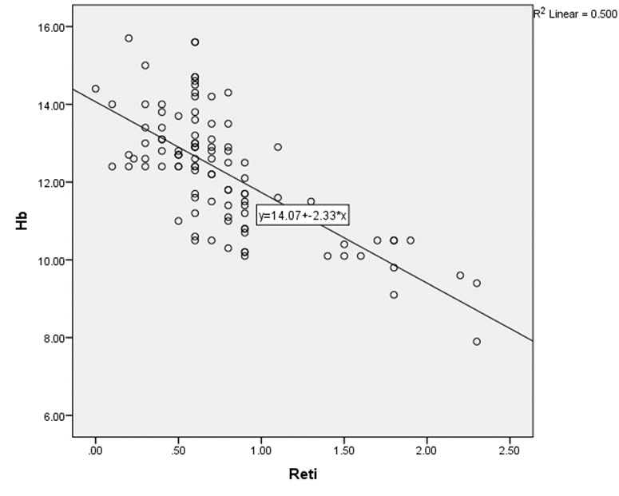 | 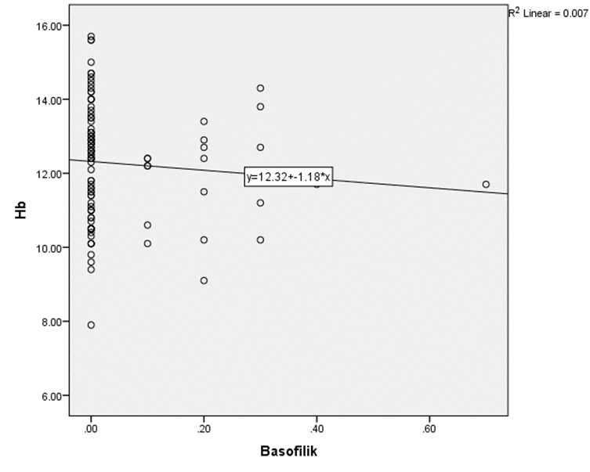 | 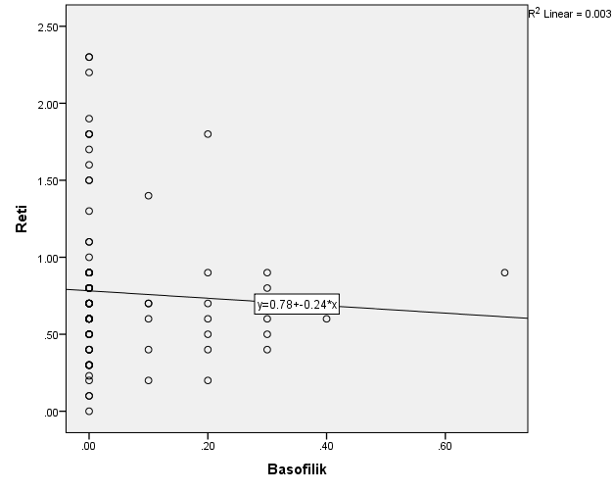
Hb and reticulocyte | Hb and basophilic stippling | Reticulocyte and basophilic stippling

Figure 2. Description of the direction of correlation of variables Hb levels, reticulocyte counts, basophilic stipling counts

Figure 2 clarifies the direction of correlation between Hb and reticulocyte counts, Hb and basophilic stippling counts, as well as reticulocyte counts and basophilic stippling. All have a negative correlation which means the higher one variable, the lower the second variable and vice versa. In the figure of correlation between Hb level and reticulocyte counts, it is clear that the graph is in accordance with the statistical test, i.e., the correlation coefficient is -0.66 and the p value is 0.00.

DISCUSSION
The average Hb level is still within its normal limit, the lowest normal limit of 12.26 gr/dl, however there were 39.4% of the population having hb level below the normal limit, with the lowest Hb level value of 7.9 gr/dl when viewed based on its normal value. Pursuant to the theory and previous study, lead exposure can reduce Hb level to cause anemia. (5) (22) Decreased Hb levels are caused by heme biosynthesis inhibition due to Pb exposure. (23) Hemoglobin consists of heme and globin molecules. Each hemoglobin molecule has four identical heme groups attached to the four globin chains. A pair of alpha chains are arranged on a pair of non-alpha chains (beta chains on adult hemoglobin). The heme molecule is composed of porphyrins and iron. Porphyrin is an integral part of the hemoglobin molecule, with the iron between the four porphyrin rings to form heme. (6) (7) The fusion of iron with porphyrins occurs in the final stage of heme synthesis through the help of the ferrochelatase enzyme. This enzyme is the final stage enzyme in the heme biosynthesis process which can be inhibited by the presence of lead. The inhibition of the ferrokhelatase enzyme causes the failure of heme biosynthesis, so as to disrupt the formation of hemoglobin. (24) As a result of disruption in the hemoglobin formation, a decrease in hemoglobin may occur, indicating a presence of anemia, in addition to other nutritional intake that affects anemia.
Studies relating to the biosynthesis process of heme have been widely carried out. Heme synthesis occurs in living cells that begin with mitochondria and end in mitochondria. (25) (26) The two starting ingredients for heme synthesis are succinyl-CoA, which originate from the citric acid cycle in mitochondria and the amino acid glycine. To activate glycine pyridoxal phosphate is needed. The combination of succinyl-CoA with glycine produces α-amino-β-ketoadipat which rapidly undergoes decarboxylation to form α-aminolevulenate (ALA), catalyzed by ALA synthase and the reaction sequence occurs in the mitochondria. Furthermore, in the cytosol, the union of two ALA molecules is catalyzed by the enzyme ALA dehydrate to form two molecules of water and porphobilinogen (PBG). ALA dehydrate has many sulfidryl groups that are sensitive to lead inhibition. In addition to obstacles in δ ALAD Lead also inhibits the coproporphyrogenogen oxidase and ferokhelatase enzymes, so that lead poisoning impacts the heme biosynthesis process. (27)
Based on normal values the reticulocyte counts ​​in 17 samples (16.35%) samples increased. According to the Kalahasthi R and Barman T study (2016), the absolute reticulocyte counts increased in 391 male battery company employees in India. (28) The increase in reticulocyte counts could be due to the decreased number of erythrocytes in the circulation. (29) The decrease in the number of erythrocytes could be caused by the shortening life span of erythrocytes due to lead exposure which can cause membrane damage. Bone marrow as a place for erythropoesis will compensate for the decrease in the number of erythrocytes in the circulation through increased erythropoiesis activity. Increased erythropoiesis activity causes immature erythrocytes such as reticulocytes to increase in circulation. The production of effective red blood cells is determined by a reticulocyte count, which assesses the functional amount made by the bone marrow. (7) Reticulocyte cells are erythrocyte cells that are still young and contain RNA residual. The reticulocyte counts can be calculated by brilliant creases blue staining that can stain the RNA residual in the cytoplasm. (30).
In this study there was a significant correlation between hemoglobin levels and reticulocyte counts, with p value of 0.00. This can be explained that the internal metabolism of erythrocytes is developed to maintain hemoglobin capable of transporting oxygen. The inhibition of heme biosynthesis due to lead exposure has caused a decrease in hemoglobin levels so that it can cause impaired erythrocyte metabolic activity in maintaining the elasticity and survival of peripheral erythrocyte cells. This condition is related to impaired development and distribution of erythrocyte cells thereby causing accelerated erythrocyte destruction. Bone marrow has the main function for erythropoiesis to produce erythrocyte cells which can carry the hemoglobin pigment to the tissues to deliver oxygen. Increased erythropoiesis in the bone marrow to meet the needs of hemoglobin due to increased destruction of erythrocyte cells, causing many erythrocyte cells such as reticulocytes to circulate peripherally. The continuous destruction of erythrocytes causes erythropoietin levels to increase and reticulocytosis begins to appear even it gives a picture of reticulocyte shift in peripheral blood. (31) (32) Percentage in peripheral blood is a useful indication to describe erythropoiesis in the bone marrow. Lead can interfere with heme synthesis, thereby changing the concentration of enzymes and intermediates in the synthesis of heme or its derivatives. Lead poisoning can cause an increase in the proportion of immature red blood cells in the blood, i.e., reticulocytes.
In this study a lot of basophilic stippling cells in erythrocytes were found, this could be explained that the lead entering the blood circulation about 90% went to erythrocytes. Erythrocyte membranes were susceptible to injury by endogenous and exogenous oxidants. Erythrocyte membranes occur in compounds or chemical reactions that can produce potentially toxic oxygen species called pro-oxidants. If the amount of pro-oxidants increases, it can cause oxidative stress. (33) Free radicals can cause oxidation to reduce glutathione (GSH) to oxidized glutathione (GSSG) through the formation of hydrogen peroxide. (34) Normally reduced intracellular glutathione (GSH) decreases oxidants. However, due to the continuous lead exposure, there will be an enzyme negligence that plays a role in glutathione metabolism and reduces the ability of erythrocytes to protect themselves from oxidative injury and cause hemolytic anemia. (35) In this condition it is mostly caused by deficiency of the glucose-6- enzyme phosphate dehydrogenase (G6PD) and inhibits the enzyme pyrimidine-5'-nucleotidase which can cause accumulation of RNA (ribo nucleid acid) and erythrocyte ribosomes characterized by the presence of basophilic stippling in erythrocytes. Oxidative stress due to lead can cause membrane damage and shorten erythrocyte life span, and G-6PD deficiency can inhibit erythrocyte maturation in the bone marrow. Regeneration of GSH in cells with G6PD deficiency will cause accumulation of hydrogen peroxide which causes denaturation of the globin chain through oxidation of sulfidryl groups. Glucose-6-phosphate dehydrogenase (G6PD) is the initial enzyme involved in the pentose phosphate pathway in erythrocyte metabolism. This enzyme catalyzes the secretion of hydrogen from glucose-6-phosphate to produce 6 phosphogluconate (6-PG) and is required for erythrocytes in inhibiting oxidative stress. This enzyme deficiency causes erythrocytes to be unable to neutralize oxidative stress which causes instability of hemoglobin and hemolysis molecules. NADPH has a very important role in reducing the glutathione system of red blood cells, the main recervatory for erythrocytes against oxidative stress and irreversible denaturation. Oxidative stress is very susceptible to erythrocytes that are old, so that the remaining cells in the peripheral blood are young cells with adequate enzyme levels to withstand stress. (36) The response of erythropoiesis in the bone marrow will trigger the entry of young cells that contain many active enzymes and reticulocytosis occurs. Thus, hemolysis due to oxidative stress because of the toxic substances such as lead is the most common clinical manifestation of G6PD anzyme deficiency.
The Hb level and the basophilic stippling counts has no significant correlation. This can be explained that the lead toxicity in human causes several negative effects, but the effect of lead exposure toxicity is highly dependent on the organ affected. In addition, the lead toxicity was also influenced by several factors, namely the level of lead toxicity that enters the body, duration of exposure, age, sex, eating habits of certain foods, physical conditions, and the ability of body tissues to accumulate metals. (23) Pb toxicity is cumulative and depending on the organ affected. If the affected is the haemopoietic system, the Pb inhibits the formation of hemoglobin systems, causing anemia. The presence of basophilic stipling in the blood does not pass through the biosynthetic pathway but rather damage to the membrane in the erythrocyte wall because Pb is pro-oxidant which causes oxidative stress and irreversible denaturation in the erythrocyte wall.

CONCLUSSION
Tambaklorok anemic population reached 39.4%. There is a correlation between hemoglobin levels and reticulocyte counts. However, there is no association between hemoglobin levels and basophilic stippling and between reticulocytes counts and basophilic stippling.

REFERENCES
1. Khusnia AZ, Astorina N, Rahardjo M. Indeks Pencemaran Lingkungan Secara Fisika-Kimia dan Biokonsentrasi Timbal (Pb) pada Kerang Hijau di Perairan Pesisir Semarang Utara. J Presipitasi Media Komun dan Pengemb Tek Lingkung. 2019;16(2):83.
2. Supriyantini E, Soenardjo N. Kandungan Logam Berat Timbal (Pb) Dan Tembaga (Cu) Pada Akar Dan Buah Mangrove Avicennia marina Di Perairan Tanjung Emas Semarang. J Kelaut Trop. 2016;18(2):98–106.
3. Tm NK. Tingkat Kualitas Udara Di Jalan Protokol Kota Semarang. Sainteknol. 2011;9(2):111–20.
4. Marianti A, Prasetya AT. Rambut Sebagai Bioindikator Pencemaran Timbal Pada Penduduk Di Kecamatan Semarang Utara. Biosaintifika J Biol Biol Educ. 2013;5(1):10–5.
5. Hegazy AA, Zaher MM, Abd MA, Morsy AA, Saleh RA. Relation between anemia and blood levels of lead , copper , zinc and iron among children. BMC Res Notes [Internet]. 2010;3(133):2–9. Available from: https://www.ncbi.nlm.nih.gov/pmc/articles/PMC2887903/pdf/1756-0500-3-133.pdf
6. Kumar V, Cotran RS, Robbins SL. Sitem Hematopoietik dan Limfoid. 7th ed. Robbins, editor. Patology. New York: Elsevier Inc; 2007. 443-446 p.
7. Sacher RA, McPerson RA. Widmann’S Clinical Interpretation of Laboratory Test. 11th ed. Phiadelhia, Pennsyvania, USA: Davis Company; 2004. 67-107 p.
8. Dongre NN, Suryakar AN, Patil AJ, Ambekar JG, Rathi DB. Biochemical effects of lead exposure on systolic & diastolic blood pressure, heme biosynthesis and hematological parameters in automobile workers of North Karnataka (India). Indian J Clin Biochem. 2011;26(4):400–6.
9. Liu C, Huo X, Lin P, Zhang Y, Li W, Xu X. Association between blood erythrocyte lead concentrations and hemoglobin levels in preschool children. Environ Sci Pollut Res. 2015;22(12):9233–40.
10. Khotijah, Sjarifa I, Mahendra PG., Widyaningsih V, Setyawan H. THE EFFECTS OF LEAD ( Pb ) EXPOSURE TO BLOOD Pb CONCENTRATION. J Kesehat Masy. 2017;13(2):286–90.
11. Purwaningsih E, Suciati Y, Widayanti E. Typhonium flagelliforme decreases telomerase expression in HeLa cervical cancer cells. Universa Med. 2016;35(1):3.
12. Kim C. Homeostatic and pathogenic extramedullary hematopoiesis. J Blood Med. 2010;1:13–9.
13. Wiczling P, Krzyzanski W, Zychlińska N, Lewandowski K, Kaliszan R. The Quantification of Reticulocyte Maturation and Neocytolysis in Normal and Erythropoietin Stimulated Rats. Biopharm Drug Dispos. 2014;36(6):330–40.
14. Santosa B, Sunoko HR, Sukeksi A. Aqueous IR Bagendit rice leaf extract decreases reticulocyte count in lead-exposed rats. Universa Med. 2018;37(1):57–64.
15. Flora G, Gupta D, Tiwari A. Toxicity of lead: A review with recent updates. Interdiscip Toxicol. 2012;5(2):47–58.
16. Corradi M, Goldoni M, Sabbadini F, Mutti A. [Acute Lead Poisoning: A Singular Case of Hemolytic Anemia and Lead Colic]. Med Lav. 2011;102(3):243–9.
17. Ali EW, Ahmed EEM. The role of erythrocyte enzyme glucose-6-phosphate dehydrogenase (G6PD) deficiency in the pathogenesis of anemia in patients on hemodialysis. Saudi J Kidney Dis Transpl. 2013;24(6):1153–6.
18. Iglessias MAC, Santos RM V., Amorim M do ST, Silva RT, Moreira SS, Barretto OCO, et al. Erythrocyte glucose-6-phosphate dehydrogenase deficiency in male newborn babies and its relationship with neonatal jaundice. Rev Bras Hematol Hemoter [Internet]. 2010;32(6):434–8. Available from: http://www.scielo.br/pdf/rbhh/v32n6/aop86010.pdf
19. Fakoor M, Akhgari M, Shafaroodi 1 and Hamed. Lead Poisoning in Opium-Addicted Subjects, Its Correlation with Pyrimidine 5′-Nucleotidase Activity and Liver Function Tests. Int J Prev Med [Internet]. 2019;10(36). Available from: https://www.ncbi.nlm.nih.gov/pmc/articles/PMC6425880/
20. Santoso B, Subagio HW, Suromo L, Sunomo HR. Zinc supplementation decreases basophilic stippling in rats exposed to lead. Universa Med [Internet]. 2014;33(1):11–8. Available from: https://univmed.org/ejurnal/index.php/medicina/article/view/15
21. Lemeshow S, W. D, Jr, Klar J. Adequacy of Sample Size in Health Studies [Internet]. 1990. p. 41–50. Available from: https://www.academia.edu/39511442/Adequacy_of_Sample_Size_in_Health_Studies
22. Hsieh NH, Chung SH, Chen SC, Chen WY, Cheng YH, Lin YJ, et al. Anemia risk in relation to lead exposure in lead-related manufacturing. BMC Public Health. 2017;17(1):1–12.
23. Agency for Toxic Substances and Disease Registry (ATSDR). Lead Toxicity Case Studies in Environmental Medicine [Internet]. Vol. WB2832, Case Studies in Environmental Medicine (Csem). 2017. p. 69–84. Available from: https://www.atsdr.cdc.gov/csem/lead/docs/CSEM-Lead_toxicity_508.pdf
24. Sassa S. Toxic Effects of Lead, with Particular Reference to Porphyrin and Heme Metabolism. In: Heme and Hemoproteins. New York; 1978. p. 333–71.
25. Moon J, Kim HR, Shin MG. Rejuvenating aged hematopoietic stem cells through improvement of mitochondrial function. Ann Lab Med. 2018;38(5):395–401.
26. Medlock AE, Shiferaw MT, Marcero JR, Vashisht AA, Wohlschlegel JA, Phillips JD, et al. Identification of the mitochondrial heme metabolism complex. PLoS One. 2015;10(8):1–20.
27. Chiu YW, Liu TY, Chuang HY. The Effects of Lead Exposure on the Activities of δ-Aminolevulinic Acid Dehydratase with the Modification of the Relative Genotypes. E3S Web Conf. 2013;1:10–2.
28. Kalahasthi R, Barman T. Effect of lead exposure on the status of reticulocyte count indices among workers from lead battery manufacturing plant. Toxicol Res [Internet]. 2016;32(4):281–7. Available from: https://www.ncbi.nlm.nih.gov/pmc/articles/PMC5080849/pdf/tr-32-281.pdf
29. Rai D, Wilson AM, Moosavi L. Histology, Reticulocytes. In: NCBI Bookshelf A service of the National Library of Medicine, National Institutes of Health [Internet]. StatPearls Publishing; 2019. Available from: https://www.ncbi.nlm.nih.gov/books/NBK542172/#_article-28438_s3_
30. Fischbach FT, Dunning MB. A Manual of Laboratory and diagnostic Test [Internet]. 8th ed. Surene H, Kogut H, editors. New York: Wolters Kluwer; 2009. 57-183 p. Available from: https://books.google.co.id/books?id=CQuBkXDspBkC&printsec=frontcover&source=gbs_ViewAPI&redir_esc=y#v=onepage&q&f=false
31. Arbach O, Funck R, Seibt F, Salama A. Erythropoietin may improve anemia in patients with autoimmune hemolytic anemia associated with reticulocytopenia. Transfus Med Hemotherapy. 2012;39(3):221–3.
32. Bierer R, Roohi M, Peceny C, Ohls RK. Erythropoietin increases reticulocyte counts and maintains hematocrit in neonates requiring surgery. J Pediatr Surg. 2009;44(8):1540–5.
33. Hoffman R, Benz EJ, Silberstein LE, Heslop H, Weitz J, Anastas J, et al. Hematology Diagnosis and Treatment_Page from Book.pdf [Internet]. 6th ed. Elsevier Health Sciences; 2013. 634-635 p. Available from: https://books.google.co.id/books?id=NIjCabJ2FQcC&pg=PA635&lpg=PA635&dq=lead+to+free+radicals+erythrocyte+membrane+to+basophilic+stippling&source=bl&ots=02GuiS0Hsu&sig=ACfU3U2wIIRlQ5mPqmdCfFtxP-SOprWxpw&hl=en&sa=X&ved=2ahUKEwjy2KuN4_7oAhVIyDgGHf-MBs8Q6AEwEXoECAoQAQ#v=onepage&q=lead to free radicals erythrocyte membrane to basophilic stippling&f=false
34. Fiser B, Jójárt B, Csizmadia IG, Viskolcz B. Glutathione - Hydroxyl Radical Interaction: A Theoretical Study on Radical Recognition Process. PLoS One [Internet]. 2013;8(9):1–8. Available from: https://www.ncbi.nlm.nih.gov/pmc/articles/PMC3767814/pdf/pone.0073652.pdf
35. Warang P, Colah R, Kedar P. Lead Poisoning Induced Severe Hemolytic Anemia, Basophilic Stippling, Mimicking Erythrocyte Pyrimidine 5’-nucleotidase Deficiency in Beta Thalassemia Minor [Internet]. Vol. 07, Journal of Clinical Toxicology. 2017. p. 8–10. Available from: https://www.longdom.org/open-access/lead-poisoning-induced-severe-hemolytic-anemia-basophilic-stipplingmimicking-erythrocyte-pyrimidine-5nucleotidase-deficiency-in-be-2161-0495-1000346.pdf
36. Brault J, Vigne B, Meunier M, Beaumel S, Mollin M, Park S, et al. NOX4 is the main NADPH oxidase involved in the early stages of hematopoietic differentiation from human induced pluripotent stem cells. Free Radic Biol Med [Internet]. 2020;146(October 2019):107–18. Available from: https://pubmed.ncbi.nlm.nih.gov/31626946/

